**Global Buzz Report**

**Africa ToP Training Course**

The first Africa’s ToP Course was held online on the 26, 27 and 28th October 2023, starting from 5pm to 11pm Kenyan time. It was funded by the Global Fund ICA-USA. The virtual ToP training targeted 3 countries and four trainees in Africa including participants from ICA Kenya, ICA Zimbabwe and ICA Zambia. ICA Kenya was represented by Nathan Ambunya, Samuel Vingo for ICA Zambia, while ICA Zimbabwe was represented by Beauty Mangere and Rugodo. This were the first beneficiaries taking the first course of this kind. The course is on a trial/researching to use ToP to train a new generation of Africa ToP trainers who will subsequently recruit participants to pay and attend the course as a self-funding system for ICAs in Africa. The training was facilitated by Beth Marie and Kim Howe. The course covered the Technology of Participation in group facilitation methods, focusing on conversation method, Consensus workshop method and, Action planning. The course also covered the navigation through virtually with both zoom and Google slide applications against the normally in person course.

**ToP Training by SCR Kenya**

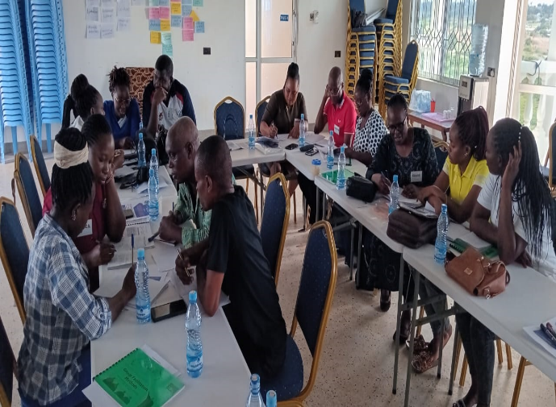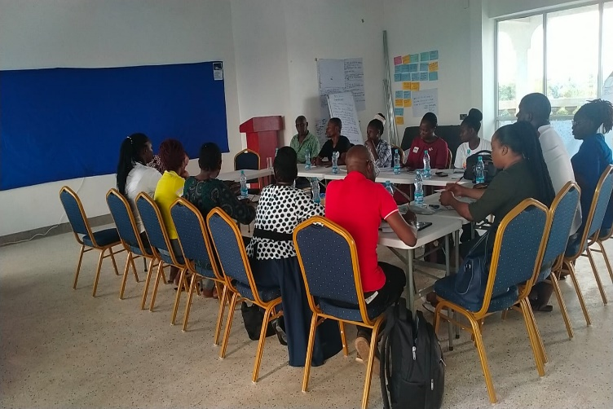A Technology of Participation (ToP) Group Facilitation Methods Training was held at Celpan Apartments, on Mariakani - Kaloleni Road, Kilifi County, 08-13/10/2023. The five-day Group Facilitation training course was organized by Support for Community Response (SCR Kenya) based in the coast region of Kenya. Day one and two were mainly demonstration of the two methods, talking about the theory behind the methods, practicing in groups and reflection on why and how’s of the methods. Funding for this training was secured from the Village volunteer programme run by ICA-UK. The training was conducted by Patrick Mbullu and Nathan Andika of ICA-Kenya, with support from Beatrice Imali of SCR. There were thirteen participants coming from a range of organisations, the majority linked to SCR – board members (3) staff (3), volunteers and associates. All participants received/accepted the training with openness and as trainers. Also, John Cornwell joined the facilitation team on the last day and demonstrated the veracity of the methods in looking at where the network wants to do over the next few years.

**Climate Change Educators Training**

The four-day training of Community Educators on Climate Change was held at Kyanduya Community Technical Training Institute (KCTTI), in Watema Location, Kee Ward, Kaiti Sub-County, Makueni County, from 18/09/2023 to 21/09/2023.

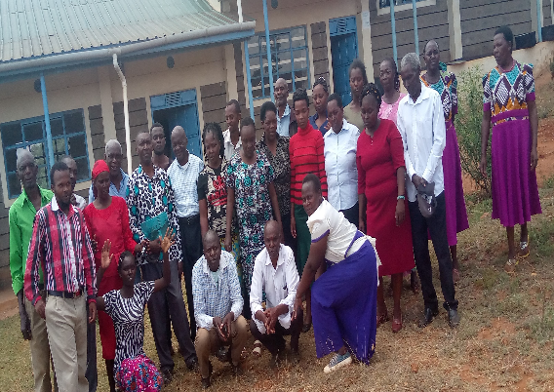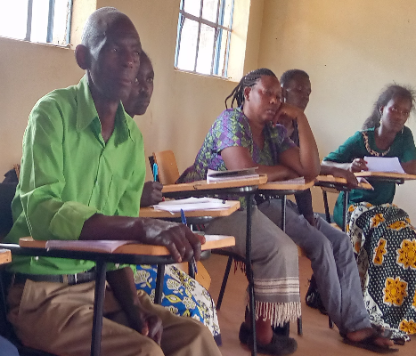*Climate Change Educators - Participants*

**ICA Kenya report Global Fund ICA-USA**

The Self Help Group (SHG) training was attended by leaders from 8 groups’ with a total of 22 participants. The participants accepted the home solar energy kits project. They also said they would want to add the water tank project using the same approach of saving and supporting each other in groups. The groups agreed to organize group meetings in their respectful groups to share information and identify those who don’t have home solar energy kits to start contributing to support each other.

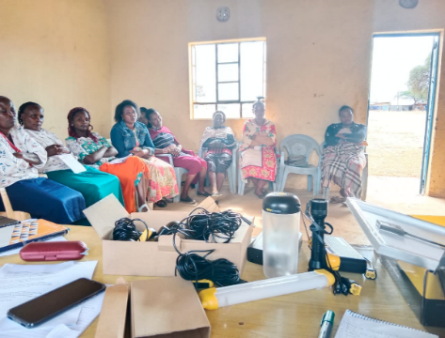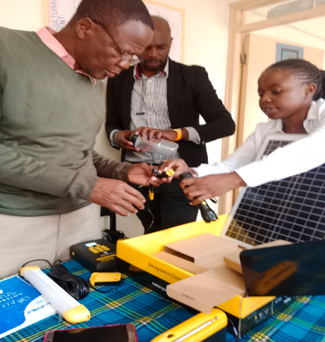



*During the SHG training and solar energy home kit demonstration*.

Explaining the solar energy home

kit parts to ICA Kenya staff